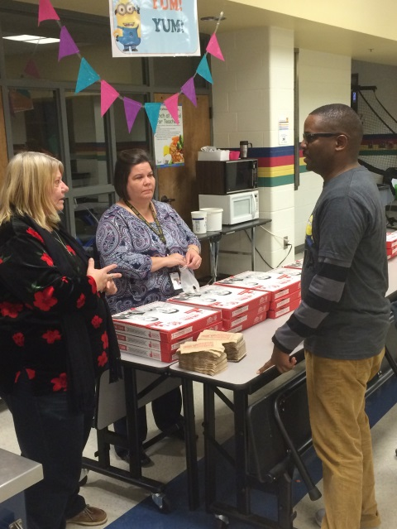

**School Plan for Shared Student Achievement** 

**What is it?**

This plan describes how Carrollton Elementary School will provide opportunities to improve family engagement to support student learning. Carrollton Elementary School values the contributions and involvement of parents and family members, as we work toward a common goal of improving student achievement. This plan describes various ways that CES will support family engagement and how parents can help plan and participate in activities and events to promote student learning at school and at home.

**How is it developed?**

Carrollton Elementary School surveyed and met with parents to obtain information about their expectations of our school and information of how CES can better support the families we serve. This information was used in the development of this Parent and Family Engagement Policy, as well as the Schoolwide Plan, the School-Parent Compact, and family engagement budget. All parental feedback received during the year via family night events, parent teacher conferences, stakeholder meetings, and emails were considered in the revisions of the plan for this school year. The CES Governance Team, Family Engagement team, and Leadership team will review the plan, make recommendations for changes, and approve the plan annually. If you have any concerns or believe changes need to be made please let us know and we will contact the district by email.

**Who is it for?**

All students participating in the Title I, part A program and their families are encouraged and invited to participate in the opportunities described in this plan. Carrollton Elementary will provide equal opportunity for all participants, including family members with limited English, with disabilities, or migratory children.

**Where is it available?**

The plan is sent home with the Trojan Tribune and grade level newsletters. Electronic copies of the plan are available on the school website and hard copies are provided in the Parent Resource Center. All publications are available in English and Spanish.

Carrollton Elementary School

***Parental and Family Engagement Policy and Plan for Shared Student Success***

*2018-2019 School Year*



*Kylie Carroll, Principal*

*401 Ben Scott Blvd.*

*Carrollton, GA 30117*

*(770) 832-2120*

*https://ces.carrolltoncityschools.net/* ***Plan Revised: September 17, 2018***

**What is Title I?**

Carrollton Elementary is identified as a Title I school as part of the Every Student Succeeds Act (ESSA).

Title I is designed to support State and local school reform efforts tied to challenging state academic standards and reinforce and enhance efforts to improve teaching and learning for students. Title I programs must be based on effective means of improving student achievement and include strategies to support parental involvement. All Title I schools must jointly develop with parents and family members a written parental and family engagement plan.



Carrollton Elementary is committed to helping our parents and families attend the family activities listed in this policy. Please call or email us if you need assistance with child care or transportation in order to participate in our programs.

Danielle Carter, Title 1 Coordinator

(770) 832-2120 ext. 4132

Danielle.carter@carrolltoncityschools.net

Let’s Get Together!

CES will host the following events as a way to build capacity for strong

family engagement that will support a strong partnership among

school, parents, and the community to improve student academic

achievement.

* Individualized Open House
  + Pre-K and Kindergarten – July 27, 2018
  + First – Third Grade – July 30, 2018
* Stakeholder Input Meeting – May 1, 2018
* School Governance Team Meetings Monthly
* Annual Title I Meeting – August 27, 2018 at 10am and 6pm
  + We invite you to an event of learning and sharing about our Title 1 program, including our parent and family engagement policy, the schoolwide plan, the school-parent compacts, and parents’ requirements.
* Parent volunteer training - August 27, 2018 and Monthly meetings at 10am and 6pm
* Family Engagement Team meetings
  + 2018 – August 16, September 20, October 18, November 15
  + 2019 – January 17, February 21, March 28
* “Come One, Come All: CES Reading Carnival”
  + September 25, 2018
* “Pixies and Pirates: Hunting for Comprehension Treasure”
  + November 13, 2018
* “NFL (Night for Family Literacy): The Game Plan for Writing”
  + January 29, 2019
* “The Wild Wild Test Prep: Preparing Your Child for Assessments”
  + March 19, 2019
* Book Fair
* Grade Level Student Showcase Nights
* Fairy Tale Ball – October 26, 2018
* Parent /teacher conferences
  + October 9-11, 2018
  + March 12-14, 2019
  + Upon request
* End of the Year Stakeholder Meeting – April 2019
* End of year celebrations

Carrollton Elementary School is committed to assisting parents that need alternate meeting times and /or transportation to these events. Please contact Kylie Carroll, Title I Coordinator, with questions or concerns - 770-832-2120.

***2018-19 District Goals***

Carrollton City Schools student achievement on End of Grade and End of Course Milestones English Language Arts assessments will increase by 3% in the combined levels of proficient and distinguished by the end of the 2019 school year.

***2018-19***

***Carrollton Elementary School Goals***

* Increase the percentage of K students achieving a STAR Early Literacy score equal to or greater than 600
* Increase percentage of students in 1st grade achieving a lexile score at or above 300 according to STAR assessment
* Increase percentage of students in 2nd grade achieving a lexile score at or above 500 according to STAR assessment
* Increase 3rd grade student achievement on the End of Grade Milestones ELA assessment by 3% in the combined proficient and distinguished levels

**School-Parent Compacts**

As part of this plan, Carrollton Elementary and our families jointly developed a school/parent compact. This compact is an agreement that parents, teachers, and students will work together to make sure all students reach grade level standards, as well as goals set forth by the parent, teacher, and student. The compacts will be reviewed at each parent/teacher conference and revised annually.

**Parent Resource Center**

There are many educational resources that can be found in the Parent Resource Center. This center is located in the CES Media Center and houses literature, games, and academic tools and activities for parents to check out and use with their child at home. Computers are available for parents to use, as well.

The Parent Resource Center is open daily!

Monday – Friday from 8:00 am to 4:00 pm.

Carrollton Elementary School is

Branching Out!

Carrollton Elementary School will take the following measures to promote and support parents and family members as an important foundation of the school, in order to strengthen the school and reach school goals. We will:

* Ensure that information related to school and parent programs, meetings, and other activities are published in both English and Spanish, posted on the school web site, social media, and included in the monthly school newsletter for all families.
* Provide professional learning for staff on strategies to improve communication with parents and ideas to increase family engagement in the areas of reading and math. Staff will also share best practices during regularly schedule grade level meetings. Input from parents will be used to develop relevant training information.
* Partner with local pre-kindergarten programs and Carrollton Middle School to ensure smooth transitions for our students from Pre-K to Kindergarten and third grade to fourth.
* Share information in English and Spanish in the school newsletter, informational flyers, or family engagement events for parents to understand the school’s academic standards and assessments as well as the ways parents can monitor their child’s progress and work with educators.
* Communicate with all families and the community on a regular basis regarding school wide events and activities, through phone messages, social media, school newsletter, flyers, etc.
* Provide necessary materials and handouts for parents at conferences, meetings, and events to help parents work with their child to improve their child’s academic achievement.
* Collect feedback from parents at events and post contact information on the school website to allow parents the opportunity to provide feedback to the school or suggestions for family engagement activities.

**Parent and Family Engagement**

Carrollton Elementary is committed to building relationships with parents and family members to foster the highest academic potential of each student. Carrollton Elementary School believes that effective family engagement is strengthened by regular two-way communication between school and home.

A parent engagement committee has been established to look at concerns and feedback from parents, generate ideas to improve parent/school relationships, and develop ways to teach parents about ways to support student learning at home. The committee includes parents, teachers, and administrators.

Additionally, this committee will continue to look for improved ways to reach out to our non-English speaking parents, to keep them informed about events and information provided from the school. These ways include, but are not limited to, printed materials in Spanish and phone calls from Spanish speaking personnel in the school, school to parent liaison, and representatives on the family engagement committee.

School Community Team

* *Yes, I am interested and wish to join the CES Family Engagement Team.*
* *Please contact me so I can learn more about joining the CES Engagement Team.*

*Name: ______________________________________________________________*

*Child’s Name and Grade: ______________________________________________*

*Homeroom Teacher: ___________________________________________________*

*Phone Number: _______________________________________________________*

*Email address: ________________________________________________________*

**Parent and Family Engagement Standards**

Carrollton Elementary School and our parents recognize and implement the National PTA Standards for Family-School Partnerships as our school’s model for engaging parents, students, and the community. These standards are:

1. Welcoming All Families
2. Communicating Effectively
3. Supporting Student Success
4. Speaking Up for Every Child
5. Sharing Power
6. Collaborating with Community

Share Your Thoughts

*We want to hear from you. If you have any suggestions or if there is any part of this plan that you feel is not satisfactory with the students’ and the school’s goals for academic achievement, please provide us with your comments in the space provided and leave this form in the front office or return it to your child’s teacher:*

*Name: (optional) ______________________________________________________*

*Telephone Number: (optional) ____________________________________________*

*Thoughts_______________________________________________________________________________________________________________________________________________________________________________________________________________________________________________________________________________________________*

**School Community Team**

Carrollton Elementary works with local organizations to support students outside of the school.

The local Boys and Girls club partners with CES to provide a mentoring program to support students with academics and social support.

Local churches and pre-school programs partner with CES to assist in providing a seamless transition into the school setting.

The University of West Georgia and CES work together to provide tutors, during the school day, to support at-risk students.

*If you would like to get involved in the parent opportunities at Carrollton Elementary School, please contact*

*Melanie Brooks:*

*Title I Coordinator*

*770-832-2120*